Data Analysis Webapp

**Link:**

<https://share.streamlit.io/ashishgopal1414/streamlit_analysis_webapp/main/main.py>

**Step 1:**

* Go to the above mentioned link and on the home page click on “Click to Upload Data” checkbox, then “Browse Files” and upload the relevant kmeans clustering results file.

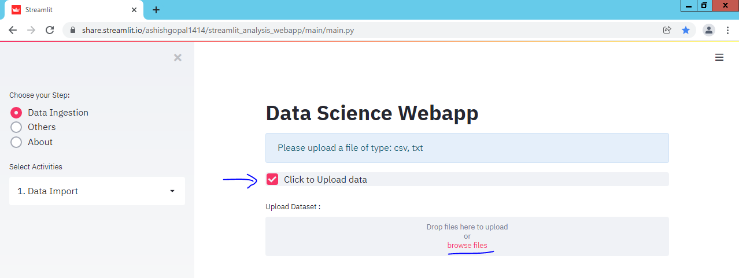

* If the upload is successful, it will show accordingly.

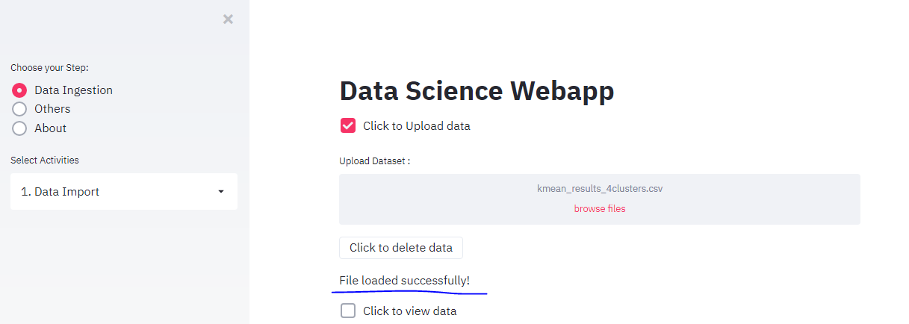

* On the left menu, select “Data Preprocess”, then on the main page select “Data Preprocess” checkbox and click on “Finally Click here to update the file” button.

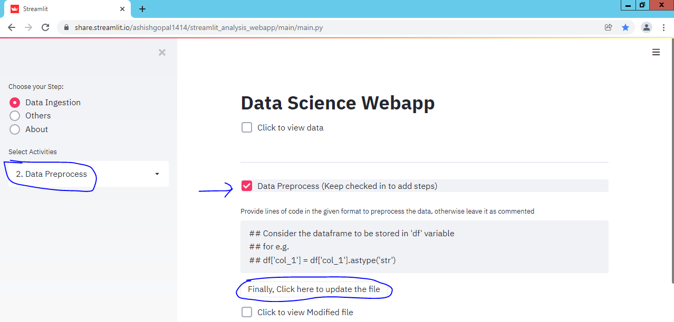

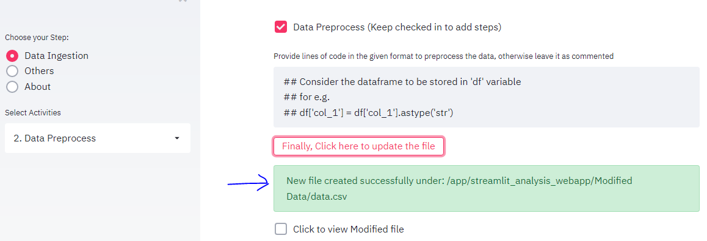

* On the left menu, select “Data Analysis”, then on the main page you can see the graph and various drop down menus which will help in filtering the data.

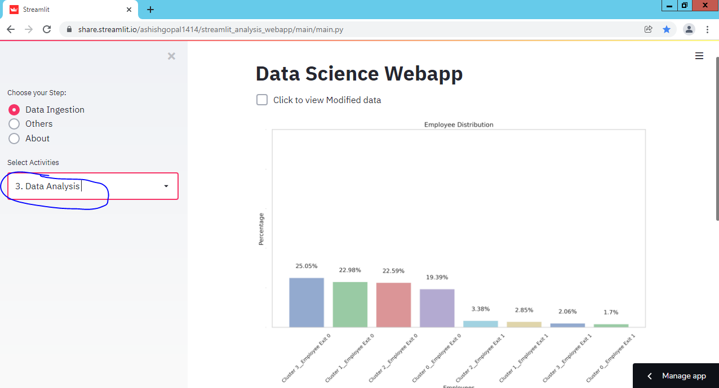

* Using the first filter we can filter for which clusters we want to explore the data, then we have 6 drill down options for various Dimensions and their values to explore the dataset. Also, I have provided a “Download Excel File” button to have the results downloaded in excel.

